Public Crime Detection System for Commoners In India

# R. Rathna1, D.Nishanth2,V.Sutharsan3,S.Barathbalaji4

1,2,3,4Department of Information technology, SRM Institute of Science & Technology, Ramapuram campus, Chennai

E-mail: [rathnar@srmist.edu.in 1](mailto:rathnar@srmist.edu.in%201) [dn6832@srmist.edu.in](mailto:dn6832@srmist.edu.in) 2 [vs3687@srmist.edu.in](mailto:vs3687@srmist.edu.in) 3

[bs7272@srmist.edu.in](mailto:bs7272@srmist.edu.in) 4

**In present world, Crime is not just limited to stealing things physically. CCTV Footage is crucial evidence against any criminal. It’s estimated that India foresees a Crime Index of 44.57 making it the 79th country by Crime Index in 2022. Well planned and structured methods can be used in overcoming these crimes. Our assessment mainly focuses in overcoming these barriers and provide efficient solution to the crimes happening around us. We aim to display proficient strategies in assessing the tools and applications needed for each scenario like house robbery, Bike theft, etc. Finding Solutions and implementation of the work is briefly displayed in this paper. The input is given as image data using real time web cam. Methodologies including the use of OpenCV, and Computer Vision are used in evaluating and finding the robbery.**

Keywords:  **Computer Vision, Tensor Flow, OpenCV, pyttsx3, Media pipe, OS, Date Time.**

1. INTRODUCTION

Many surveillance cameras had been mounted in stations, industrial facilities, and town regions to discourage crime. However, because the wide variety of cameras increases, the extent of video records has additionally emerged as massive. This makes it nearly it not possible for the police and protection corporations to visually reveal for suspicious behavior and crime through checking and studying pix and motion pictures manually. To deal with this challenge, synthetic intelligence (AI) is getting used withinside the combat in opposition to crime.

Police offerings round the arena are actively operating to apply AI for video evaluation and crook investigation, with a circulate closer to predictive crime detection and prevention primarily based totally at the idea of proactive, as opposed to reactive, crime fighting. AI learns round one hundred kinds of moves as primary moves in advance: from easy moves which include strolling and stopping, to greater complicated moves and moves which include turning the top to the proper and elevating the left hand.

These primary moves may be identified with a median accuracy of ninety percentage or greater. The proposed Crime Detection System the use of OpenCV and AI includes detecting moves and figuring out the individual’s face the use of pc imaginative and prescient. The idea additionally includes fetching the individual’s call and different data from the backend database and showing to the consumer for powerful identity with more accuracy Recognition accuracy of suspicious behavior may be in addition delicate after the device's introduction. This may be accomplished through specifying extra behavioral conditions, which include turning the top left and proper to appearance round, and through converting evaluation parameters, which include every action’s duration. The sub-utility called Robbery detection device alarms whilst a unknown individual enters the digital digicam imaginative and prescient zone. If it detects an unknown individual the device alarms the occupant of the area.

1. RELATED SURVEY

“Writing Overview on Criminal Recognizable proof in Mumbai utilizing DBSCAN, Akshay Rathod, Rushikesh Sawant, Ashish Choudhary, Neha Singh”, Crime percentages are expanding consistently in India, with Mumbai being the third among the 19 urban communities for 3 back toback years; protection from wrongdoing should be given expanded need by the public authority as well as people. In this paper, writing overview of wrongdoing examination utilizing DBSCAN grouping on wrongdoing dataset is finished.

“An Overview on Wrongdoing Event Location and forecast Procedures, Shruti S.Gosavi, Shraddha, S. Kavathekar”, Discoveries of this overview were that when the dataset occasions have more number of missing qualities pre-handling turns into an essential undertaking and wrongdoing doesn't happen consistently across metropolitan scenes however moves in specific regions. In thisway, foreseeing wrongdoing areas of interest is a vital undertaking likewise applying post-handlingwill help in bringing down the pace of violations.

“Writing review on video observation wrongdoing action acknowledgment, K Kishore Kumar, “This paper presents an outline of present and past audits for creating future exploration. The distributed diaries from 2000-2020 were dissected to be aware of the video observation and wrongdoing identification techniques in various areas. A survey of the examined scientists and their strategies are accessible in this paper. This overview is valuable to further develop the wrongdoing location methods utilizing video observation. Besides, it is a helpful device to accumulate data.

“Investigation for wrongdoing counteraction utilizing ICT, Yulihño Ochante-Huamaccto, Francis Robles-Delgado, Michael Cabanillas-Carbonell,” Wrongdoing is a social issue that after therepression of Coronavirus has expanded essentially around the world, which is the reason it is vital to understand what mechanical devices can be utilized to forestall criminal demonstrations. In thecurrent work, a fundamental examination was completed to decide the significance of how to forestall wrongdoing utilizing new data innovations. Fifty examination articles were chosen somewhere in the range of 2015 and 2021. The outcomes got tell explicit data on the best way to forestall wrongdoing utilizing new data innovations.

“Overview on wrongdoing investigation and forecast utilizing information mining methods, H. Benjamin Fredrick David and A. Suruliandi,” Information Mining is the technique which incorporates assessing and analyzing enormous prior data sets to produce new data which might be vital for the association. The extraction of new data is anticipated utilizing the current datasets. 6 Many methodologies for examination and expectation in information mining had been performed. Yet, numerous couples of endeavors has made in the criminal science field. Numerous couples of have taken endeavors for looking at the data this multitude of approaches produce. The police headquarters and other comparative law enforcement offices hold numerous huge data sets of data which can be utilized to anticipate or dissect the criminal developments and crime association in the public. The crooks can likewise be anticipated in view of the wrongdoing information.The fundamental point of this work is to play out a study on the directed learning and unaided learning strategies that has been applied towards criminal ID. This paper presents the review on the Wrongdoing examination and wrongdoing expectation utilizing a few Information Mining procedures.

“Experimental Examination for Wrongdoing Expectation and Anticipating Utilizing AI, Wajiha safat, Sohail asghar, Saira andleeb gillani,” Wrongdoing and infringement are the danger to equity and intended to be controlled. Exact wrongdoing expectation and future anticipating patterns can help to computationally upgrade metropolitan wellbeing. The restricted capacity of people to handle complex data from huge information frustrates the early and precise expectation and anticipating of wrongdoing. The exact assessment of the crime percentage, types and problem areas from past examples makes numerous computational difficulties and open doors. In spite of significant examination endeavors, yet there is a need to have a superior prescient calculation, which direct police watches toward crimes. Past investigations are missing to accomplish wrongdoing gauging and forecast exactness in view of learning models. Consequently, this studyapplied different AI calculations, specifically, the strategic relapse, support vector machine(SVM), Guileless Bayes, k-closest neighbors (KNN), choice tree, multi-facet perceptron (MLP), arbitrary woodland, and Outrageous Slope Helping (XGBoost), and time series investigation by lengthy transient memory (LSTM) and autoregressive incorporated moving normal (ARIMA) model to fit the wrongdoing information more readily. The exhibition of LSTM for time series examination was sensibly sufficient arranged by greatness of root mean square blunder (RMSE) and mean outright mistake (MAE), on the two informational collections.

“Hypothetical and Observational Examination of Wrongdoing Information, Manisha Mudgal, Deepika Punj and Anuradha Pillai,” Wrongdoing is one of the greatest and overwhelming issues inthis day and age and it isn't simply hurtful to the individual in question yet in addition to the localarea and government. Because of heightening in wrongdoing recurrence, there is a requirement fora framework that can identify and foresee violations. This paper portrays the rundown of the various strategies and methods used to recognize, investigate and anticipate forthcoming and present violations. This paper shows, how information mining strategies can be utilized to recognize and anticipate wrongdoing utilizing affiliation mining rule, k-implies grouping, choice tree, fake brain organizations and profound learning techniques are additionally made sense of. The majority of the explores are as of now dealing with determining the event of future wrongdoing. There is a requirement for approaches that can deal with constant wrongdoing expectation at high velocity and exactness. In this paper, a model has been recommended that can deal with ongoing wrongdoing expectation by perceiving human activities.

“Wrongdoing expectation and interruption discovery with iot and AI, Anirudh Kumar Tiwari Prof. (Dr.) Bhavana Narain,” The reason for our work is to plan a model that helps the police in distinguishing wrongdoing areas. We have taken a condition that in the event that any individual is heading off to some place and in the wake of seeing a mishap, when the photograph of that mishap is taken then naturally it will be shipped off closest police headquarters. For this, it is important to have an application planned by us both in the shipper and the recipient. This entire matter will straightforwardly interface the police no sweat the police can arrive at that area. GPS will be utilized for area location. In our work we have gathered dataset with the assistance of computerized camera which is connected with IoT gadget. In initial segment of our paper we have examined the grounds of our work under presentation of wrongdoing, advanced picture handling, GPS and IoT. In second piece of our work we have examined the system of our work here sensor board, GPS setting has been talked about alongside dataset. There is various information assortment advances in the IoT. The most broadly utilized innovation is the Remote sensor organization (WSN) utilizes multi-jumping and self-association to keep up with command over the correspondence hubs.

“Wrongdoing Identification Procedure Utilizing Information Mining and K-Means, Khushabu A. Bokde, Tiksha P. Kakade, Dnyaneshwari S. Tumsare,” Wrongdoings will some way or another impact associations and establishments when happened oftentimes in a general public. Consequently, it appears to be important to concentrate on reasons, elements and relations betweenevent of various wrongdoings and tracking down the most fitting ways of controlling and stay away from additional violations. The fundamental target of this paper is to group bunched violations in view of event recurrence during various years. Information mining is utilized widely with regards to examination, examination and disclosure of examples for event of various wrongdoings. We applied a hypothetical model in view of information mining strategies, for example, bunching and grouping to genuine wrongdoing dataset kept by police in Britain and Grains inside 1990 to 2011. The Hereditary Calculation (GA) is utilized for advancing of Anomaly Recognition administrator boundaries utilizing RapidMiner apparatus.

“Criminal face recognition framework, shiva tamrkar,” Criminal Face Identification project expects to construct a robotized Criminal Face Location framework by turning the human capacity to review minute facial subtleties. Distinguishing proof of lawbreakers at the location of a crime can be accomplished in numerous ways like fingerprinting, Potential observers to a wrongdoing have seen the crook however by and large it may not be imaginable to see the substance of the culprit totally. The Lawbreaker Face Discovery Framework will be worked of a current criminal data set. Information would be given as sketch or a picture and matched against the current data set and results would be given. Criminal record by and large contains individual data about specific individual alongside photo.

1. SYSTEM MODULES

A. Flask Module

Flask is a microframework written in python and it’s used for web applications which requires minimal operations and high performance. Flask is easy to use. When the user opens the website, The website will send the data to web server and web server sends response to the WSGI server. WSGI server is an important component as it is used to send requests from web server to python(backend). WSGI server is known as Web server gateway interface. The data is received by python application and the data is analyzed respective to the purpose of the application. The further process will be taken care of GET and POST requests simultaneously. GET request is used to collect the input from the user. It also deletes all representation of the target resource specified in the link. The data is collected through GET and transfers to the view function. We can analyze the mentioned process and features in the above diagram Fig 1.

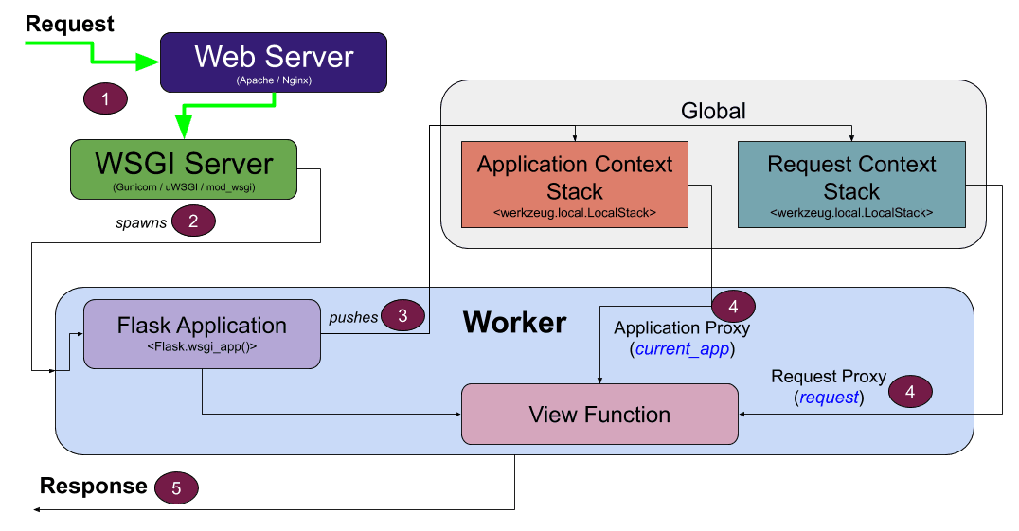

Fig 1: Flask Module

B. ADABOOST Module

ADABOOST algorithm is known as adaptive boost algorithm. It is used to boost the python applications. This algorithm achieves high accuracy. This algorithm has a preprogrammed trainer inbuilt with weak classifiers. The weak classifiers help to classify the images in the application. It’s a supervised learning and it has already pre trained data inserted. OpenCV has a module named HAAR Cascade classifier. ADABOOST is hidden under HAAR cascade classifier. The HAAR cascade is a powerful algorithm which uses edge or line detection to detect the face. The result is stored in xml files and its read by Open CV methods. ADABOOST is a extension to the HAAR cascade to boost the algorithm. The HAAR features needed a lot of mathematical calculation to traverse the face. The features and architecture is mentioned clearly in FIG 6.2.

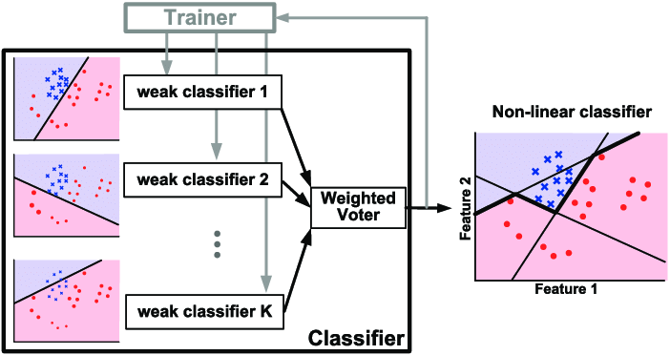

Fig 2: ADABOOST Module

C. OpenCV Module

Open CV is a python module which is used in applications which uses face comparisons. OpenCV 14 has a front end of G-API OpenCV Module. The front end uses Core classes of GMat and standard kernel library of API definitions. The data is sent to abstract data engine (ADE). The data is than analyzed using G-API domain graph logic and ADE Backend interface. The data than splitted into Naive scheduler and wrapped OCV. The HAAR Classifiers comes into action, and it classifies the data. In simple words, Open CV is a computer vision library with APIs that let you setup a pipeline for your computer vision project. It also provides implementation for many computer vision algorithms along with image algorithms. The process is shown in Fig 6.3 Open CV architecture diagram.

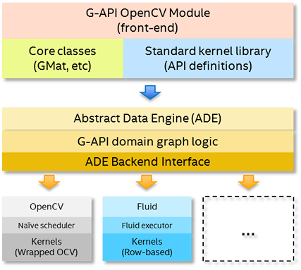

Fig 3: OpenCV Module

IV. RESULT AND DISCUSSION

Ada boost Classifier algorithm combines weak classifier algorithms to create a strong classifier. The accuracy rate of this algorithm will be high when comparing to other algorithms. After training a classifier at any level the Adaboost algorithm assigns weight to each classifier based on accuracy to categorize the classifier into weak and strong.

$H(X)=Sign(\sum_{t=1}^{T}{α_{n}h_{n}(x))}$ (3)

Ht(x) is the output of weak classifier t for input x. alpha_t is weight assigned to classifier.

Alpha_t = 0.5*log((1-E)/E) – This formula is based on the error rate E.

The accuracy can be calculated as – (Total_positive+Total_negative)/(Total)

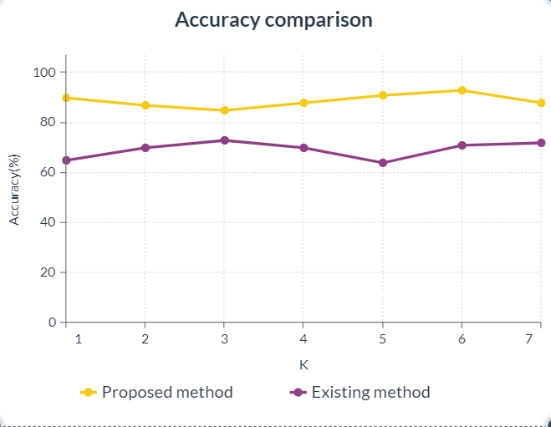

Fig 4: Accuracy comparison

Fig 8.1 shows a clear comparison of the accuracies between the proposed system and the existing system. This graph also depicts the accuracy percentages of both the systems. The Adaboost algorithm efficiency is improvised as we can depict from the above graph. The accuracy of the proposed system starts at 90% and we can see the rise from level 3 to level 6. The majority value is 95%. The existing system starts at 63% and we can depict a downfall from level 3 to 5. The majority value is 75% for the existing system. This proof depicts that Adaboost algorithm provides high performance in accuracy and efficiency.

TABLE 1: Performance metrics

|  |  |
| --- | --- |
| Learning rate | Test accuracy (%) |
| 0.1 | 95 |
| 0.2 | 75 |
| 0.3 | 94 |
| 0.4 | 98 |
| 0.5 | 98 |
| 0.6 | 94 |
| 0.7 | 99 |
| 0.8 | 97 |
| 0.9 | 93 |
| 1 | 83 |

The table 1 gives the values for the performance of the system in respect to learning rate. As per the table we can easily depict that the accuracy of the algorithm used in the system. The high accuracy is at learning rate of 0.4 and 0.5.

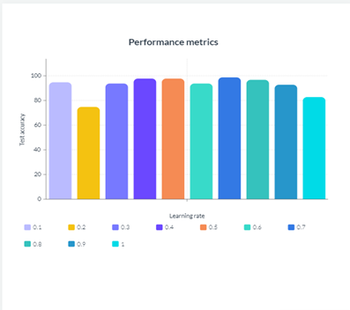

Fig 5: Performance Metrics of alpha

As we can see the performance metrics are in the range of 80%-100% accuracy. The performance metrics are high in percentage.

Fig 6: Datasets analysis of proposed and existing method

The error rate is decreasing as alpha decreases. The proposed system is a good choice for crime detection and web cam applications. Hereby, I conclude that the proposed system is accurate and approximate.

V CONCLUSION

The public crime detection system for commoners helps all kind of public in residential areas and in public places too. This system is highly effective and gears the nation security above the existing systems. This system is also easy to maintain, and it gives an ease of access to all the users. This paper explains about the deployment of criminal detection system, Modules integrations, Webcam integrations and much more. This is a very useful project as it can protect our homes and nation. The website is quick responsive, fast, and feasible.

REFERENCES

[1] Akshay Rathod, Rushikesh Sawant – “Writing Overview on Criminal Recognizable proof in Mumbai utilizing DBSCAN “, Vol 12 No SUP 1 (2020): SAMRIDDHI: A Journal of Physical Sciences, Engineering and Technology.

[2] Ashu Kumar, Amandeep Kaur – “Face Detection Techniques: A Review”, Artificial Intelligence Review 52(1) DOI:10.1007/s10462-018-9650-2

[3] Xinghua Fan, Fuyou Zhang – “The system of face detection based on OpenCV”, 2012 24th Chinese Control and Decision Conference (CCDC), 2012, pp. 648-651, Doi: 10.1109/CCDC.2012.6242980.

[4] Kruti Goyal, Kartikey Agarwal – “Face detection and tracking: Using OpenCV”, 2017 International conference of Electronics, Communication and Aerospace Technology (ICECA), 2017, pp. 474-478, Doi: 10.1109/ICECA.2017.8203730.

[5] Mamata s.Kalas – “Real time face detection and tracking using opencv”, IRF International Conference, 5th & 6th February 2014, Pune India. ISBN: 978-93-82702-56-

[6] Kushsairy Kadir, Mohd Khairi Kamaruddin – “A comparative study between LBP and Haar-like features for Face Detection using OpenCV”, 2014 4th International Conference on Engineering Technology and Technopreneuship (ICE2T), 2014, pp. 335-339, Doi: 10.1109/ICE2T.2014.7006273

[7] Jian-Ming Liao – “Face detection based on adaboost”, 2009 International Conference on Apperceiving Computing and Intelligence Analysis, IEEE

[8] S.V. Viraktamath, Aditya Khatawkar – “Face Detection and Tracking using OpenCV”, The Standard International Journals (The SIJ), ISSN: 2321 – 2403

[9] Dai Chen, Ji-lin Wang – “Face Detection Method Research and Implementation Based on Adaboost”, 2010 International Symposium on Intelligence Information Processing and Trusted Computing, 2010, pp. 643-646, doi: 10.1109/IPTC.2010.125.

[10] H.W. Liu, G. Wang, and G.W. Zhang – “Research of AdaBoost Face Detection and OpenCV Implementation”, AMM 2014;651–653:482–5. https://doi.org/10.4028/www.scientific.net/amm.651-653.482.

[11] Rong Fu, Dan Wang – “University Classroom Attendance Based on Deep Learning”, 2017 10th International Conference on Intelligent Computation Technology and Automation (ICICTA), 2017, pp. 128-131, doi: 10.1109/ICICTA.2017.35.